Where in the World is Petrified Forest
Petrified Forest
Distance Learning Program

Pre-program lessons: Complete the following “Pangea Puzzle” and “Where is your school” activities prior to the distance learning program.

Petrified Forest Focus: general park background, geology
School Subjects: geology (continental drift), math, geography
Grade Level: 4th, 5^{th,} & 6th
Time Required: Pre-program lessons - One or two class periods (60-90 minutes) Distance learning program - 45 min

Common Core standards addressed:

K-12 Literacy and Writing
- CCSS.ELA-LITERACY.CCRA.R.2 - Determine central ideas or themes of a text and analyze their development; summarize the key supporting details and ideas.
- CCSS.ELA-LITERACY.CCRA.R.7 - Integrate and evaluate content presented in diverse media and formats, including visually and quantitatively, as well as in words.
- CCSS.ELA-LITERACY.CCRA.W.7 - Conduct short as well as more sustained research projects based on focused questions, demonstrating understanding of the subject under investigation.
Science and Technical Text 6-8th grades
- CCSS.ELA-LITERACY.RST.6-8.1
Cite specific textual evidence to support analysis of science and technical texts.
- CCSS.ELA-LITERACY.RST.6-8.3
Follow precisely a multistep procedure when carrying out experiments, taking measurements, or performing technical tasks.
- CCSS.ELA-LITERACY.L.4.6
Acquire and use accurately grade-appropriate general academic and domain-specific words and phrases, including those that signal precise actions, emotions, or states of being (e.g., quizzed, whined, stammered) and that are basic to a particular topic (e.g.,wildlife, conservation, and endangered when discussing animal preservation).
Math
4th grade
- CCSS.MATH.CONTENT.4.OA.A.3 - Solve multistep word problems posed with whole numbers and having whole-number answers using the four operations, including problems in which remainders must be interpreted
- CCSS.MATH.CONTENT.4.MD.A.2 - Use the four operations to solve word problems involving distances, intervals of time, etc.
5th grade
- CCSS.MATH.CONTENT.5.NBT.A.1 - Recognize that in a multi-digit number, a digit in one place represents 10 times as much as it represents in the place to its right and 1/10 of what it represents in the place to its left.
- CCSS.MATH.CONTENT.5.NBT.A.3.A - Read and write decimals to thousandths using base-ten numerals, number names, and expanded form.
- CCSS.MATH.CONTENT.5.NBT.A.4 - Use place value understanding to round decimals to any place.
- CCSS.MATH.CONTENT.5.NBT.B.5 - Fluently multiply multi-digit whole numbers using the standard algorithm.
- CCSS.MATH.CONTENT.5.MD.A.1 - Convert among different-sized standard measurement units within a given measurement system (e.g., convert 5 cm to 0.05 m), and use these conversions in solving multi-step, real world problems.
6th grade
- CCSS.MATH.CONTENT.6.RP.A.3.B - Solve unit rate problems including those involving unit pricing and constant speed.
- CCSS.MATH.CONTENT.6.RP.A.3.D - Use ratio reasoning to convert measurement units; manipulate and transform units appropriately when multiplying or dividing quantities.
- CCSS.MATH.CONTENT.6.NS.B.2 - Fluently divide multi-digit numbers using the standard algorithm.
- CCSS.MATH.CONTENT.6.EE.B.7 - Solve real-world and mathematical problems by writing and solving equations of the form x + p = q and px = q for cases in which p, q and x are all nonnegative rational numbers.

AZ Science Standards
- SC04-S2C2, SC05-S2C2, SC06-S2C2: Nature of scientific knowledge; Understand how science is a process for generating knowledge.
- SC04-S1C4-03, SC05-S1C4-03: Communicate with other groups or individuals to compare the results of a common investigation.
- SC07-S6C1-03: Explain the following processes involved in the formation of the Earth’s structure: Erosion; deposition; plate tectonics; volcanism
- SC04-S1C1, SC05-S1C2-04: Use metric and U.S. customary units to measure objects; measure using appropriate tools and units of measure.

Materials Needed
For ‘Pangea Puzzle’ Activity:
- copies of Pangea puzzle handout (per pair or group)
- scissors (1 per student)
- clear tape (enough to share)
For ‘Where is Your School?’ Activity:
- Maps of the United states
- Rulers or tape measures
- Pencil and paper
Lesson Overview
Students learn the basic concepts of plate tectonics and how scientists determine that land masses on earth have changed position over time by correlating the existence of identical fossils and geology on different land masses. This lesson also serves as an introduction to the environment that existed during the Late Triassic time period in what is now Petrified Forest National Park. Students will practice math skills while learning where Petrified Forest National Park and their school are located on a map of the U.S. Both pre-visit lessons will then be used to interact with a live ranger from Petrified Forest during a 45 minute distance learning session.

Lesson Objectives (including pre-program activities):
Students will be able to
- Locate Arizona, Petrified Forest NP, and the state where their school is located on a map of the United States
- Use the scale of a map to determine actual distance between two locations
- calculate distance, time, and speed using multiplication and division
- convert a quantity of hours that contains decimals into a measurement of hours and minutes (ex 2.5 hours = 2 hours and 30 minutes)
- describe the differences between the current locations of the continents on Earth and where they were located during the Triassic
- describe the basic concepts of plate tectonics and fossil correlation over different land masses.

Background information:

Petrified Forest National Park is located in a unique landscape of colorful eroded badlands and contains one of the highest concentrations of fossilized wood in the world. The story of Petrified Forest today cannot be told without having an understanding of the current and past locations of the Earth’s continents. Understanding the concepts of plate tectonics also helps students understand the current and possible future world landscape.

The fossils found within the park, including the trees, and the park’s geology represent an ancient subtropical environment, very different from the park’s current semi-arid grassland environment. This sub-tropical environment existed over 200 million years ago during the Late Triassic epoch. The geology and fossils within the park represent approximately 18 million years of that time. The position and topography of the land masses during the late Triassic provides part of the explanation to why we now find tropical plant fossils and sediments of a river within Petrified Forest. During that time the land that is now the park was just north of the equator at around the same latitude that Panama is currently located.

Pangea (Pangaea) is the name given to the supercontinent that existed during the late Triassic epoch when all of Earth’s land masses were connected into one giant land mass. Studies of correlated fossils and geologic features of the now separated lands have enabled scientists to see how they were positioned in the past. Fossils of identical animal species found today on lands that are separated by distances too far for those animals to have traveled indicate that the lands were once joined.

In alignment with the goals of the National Park Service, helping students (who are potential visitors and stewards) understand the location of national parks in general and specifically of Petrified Forest NP is a cornerstone of education programs provided by the park. It is particularly beneficial to students participating in a distance learning program such as this one to give them a context for the rangers they are interacting with.

Procedures:

- Review the background information above with the students and complete the ‘Pangea Puzzle’ and “Where is Your School?’ activities (30-45 min each) prior to the distance learning program.

- Encourage your students to create a list of questions prior to the distance learning program. They will have an opportunity to present these questions to the Park Rangers during the last five to ten minutes of the program. Please guide your students in writing thoughtful questions.

- Optional after post program activity: Students can research the differences between the current environments where they live and at Petrified Forest National Park to write a one page comparative essay or an informational display board.

Example Research Questions:
- What is the environment of each area called?
- What are the average annual high and low temperatures of each area?
- What are the average precipitation rates of each area?
- What kinds of animals and plants live in each area?
- When is a good time to plant your summer vegetable garden in each area?

During the Distance Learning Program (45 min)
Materials needed:
- Completed “Pangea Puzzle” and “Where is your School? activity worksheets for reference.
- Large map of the U.S. hung on a wall

The ranger will begin by introducing himself/herself and conducting a short activity on the mission of the National Park Service. This section of the program will cover what national park sites are in AZ and the state that the school is located along with general knowledge of how students can be good stewards of their national parks. The ranger will then give a general background of Petrified Forest National Park and how geologic changes have contributed to the current landscape. 10 Minutes
- The next part of the program will cover the “Where is your school?” activity giving the students an opportunity to share their answers with the ranger. The teacher will call on individual students to provide answers. The ranger will have a backdrop of the map of the US behind them to show locations. Students can use a classroom map to do the same thing.
- The second part of the program looks into the concepts of plate tectonics and how they are related to the story of Petrified Forest NP. Students can have their completed Pangea Puzzles for reference. The ranger will have a large version of this activity as a backdrop and students will help the ranger put the pieces back together using the correlation of current fossils and geology.
- The last 10-15 minutes of the program with be an ‘ask the ranger’ session. Please have students create thoughtful questions and send them ahead of the program so the ranger can prepare.

*Although this program and included activities address the curriculum standards, it remains the responsibility of the individual teacher to determine the extent to which the standards have been met based on program content, pre- and post- activities, and appropriate evaluation of student learning and understanding.
Pangea Puzzle Activity
Distance Learning Pre-program Activity #1

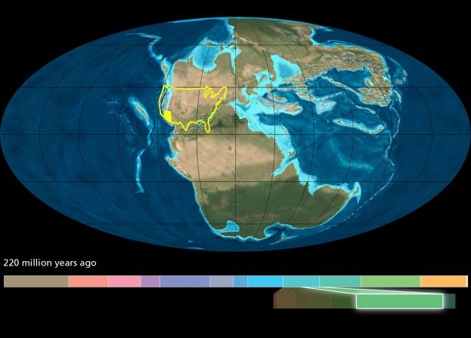
Materials needed:
- copies of Pangea puzzle (per pair or group)
- scissors (1 per student)
- clear tape (enough to share)
Time required: 30-45 minutes

Lesson Overview
Students learn basic concepts of plate tectonics and how scientists determine that land masses on earth have changed position over time. This lesson also serves as an introduction to the environment that existed during the Late Triassic time period in what is now Petrified Forest national park.
Lesson Objectives
- Students will be able to understand the difference between the current locations of the continents on Earth and where they were located during the Triassic
- Students will be able to describe the basic concepts of plate tectonics and fossil correlation over different land masses.

Vocabulary:
Continent: one of the seven main continuous land masses on Earth
Tectonic plate: large moveable segment of the Earth’s crust that interacts with other plates and causes continental drift, earthquakes, volcanoes, mountains, and oceanic trenches. Oceanic plates are made of basalt and are heavier than the continental plates which are made mostly of granite. This causes the plates to subduct, or sink, under one another.
Epoch: a subdivision of geologic time; The Triassic period is divided into three epochs
Lithosphere: the rigid outer part of the earth, consisting of the crust and upper mantle.
Fossil: evidence of life preserved by a geologic process
Glacial Scarring: large gouges in the land created by glaciers moving over it. These scars run in patterns moving away from where the ice started.
Mountain Range: series or chain of mountains that is close together

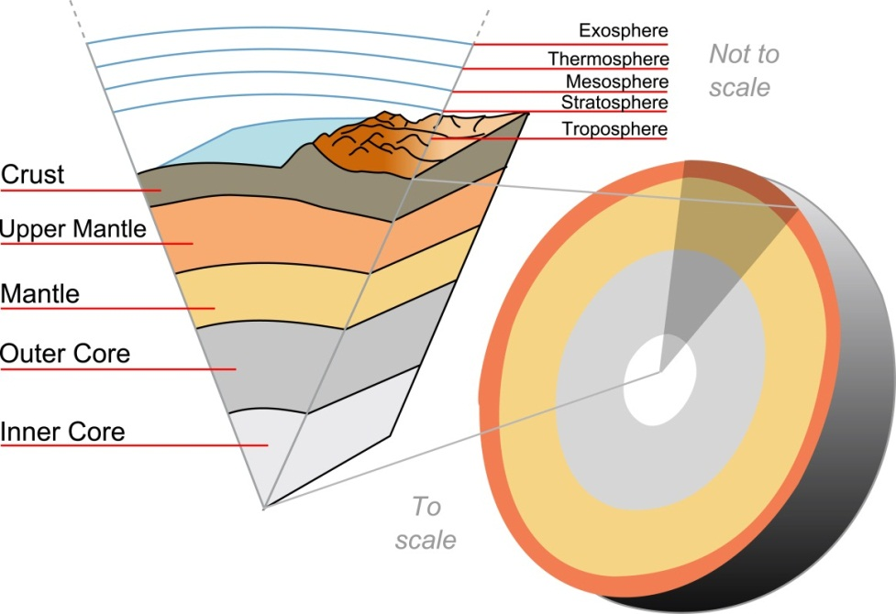
Layers of the Earth:

"Earth-crust-cutaway-english" by Surachit http://commons.wikimedia.org/wiki/File:Earth-crust-cutaway-english.svg#mediaviewer/File:Earth-crust-cutaway-english.svg

Background:
During the late Triassic epoch, over 200 million years ago, all of the land masses on Earth were joined together in one super continent we now call Pangea (Pangaea – which means ‘all lands’ in Greek). The continents have since moved apart into their current positions due to movement of the Earth’s lithosphere and Plate tectonics (sinking under each other). A German scientist named Alfred Wegener was the first to establish a theory of how the Earth’s land masses move around and how they were once connected together.
“Tectonic Activity - At first, other scientists did not accept Wegener’s theory of continental drift. But scientists now know that the continents rest on massive slabs of rock called tectonic plates. The plates are always moving and interacting in a process called plate tectonics. Over time, tectonic activity changes the Earth’s surface, rearranging and reshaping its landmasses.
Today, scientists believe that several supercontinents like Pangaea have formed and broken up over the course of the Earth’s lifespan. These include Pannotia, which formed about 600 million years ago, and Rodinia, which existed more than a billion years ago.
The continents are still moving today. Underwater exploration has revealed seafloor spreading. Seafloor spreading is the process of new crust forming between two plates that are moving apart. Along a network of mountain ranges in the ocean, molten rock rises from within the Earth and adds new seafloor to the edges of the old. As the seafloor grows wider, the continents on opposite sides of the ridges move away from each other.” – National Geographic
By looking at the fossils and geology of the continents now, scientists can piece together what the Earth’s land masses used to look like. For example they can match fossils of the same species, from the same time, on the east side of South America to fossils on the west side of Africa. Mountain ranges like the Appalachian Mountains and glacial scarring on the African continent are also ways that scientists can match past land formations.
Extra resources on Plate tectonics: http://education.nationalgeographic.com/education/encyclopedia/continental-drift/?ar_a=1
Procedure:
- This activity can be done in pairs or groups.
- Students cut out each continental shape and use the map key symbols as guides to match the continents to their orientation during the Triassic.
- Use clear tape to hold the pieces together.
- Check the student’s work against the answer key.

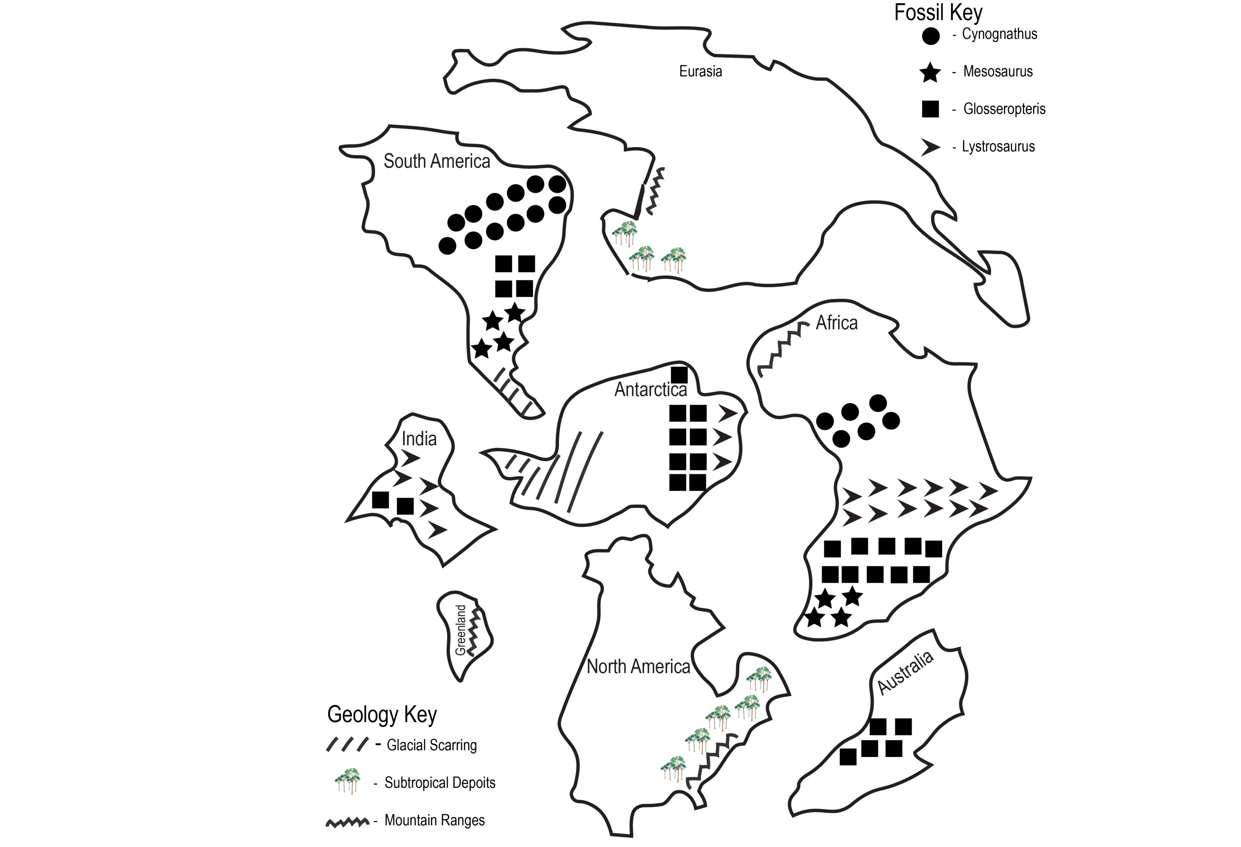
Pangea Puzzle

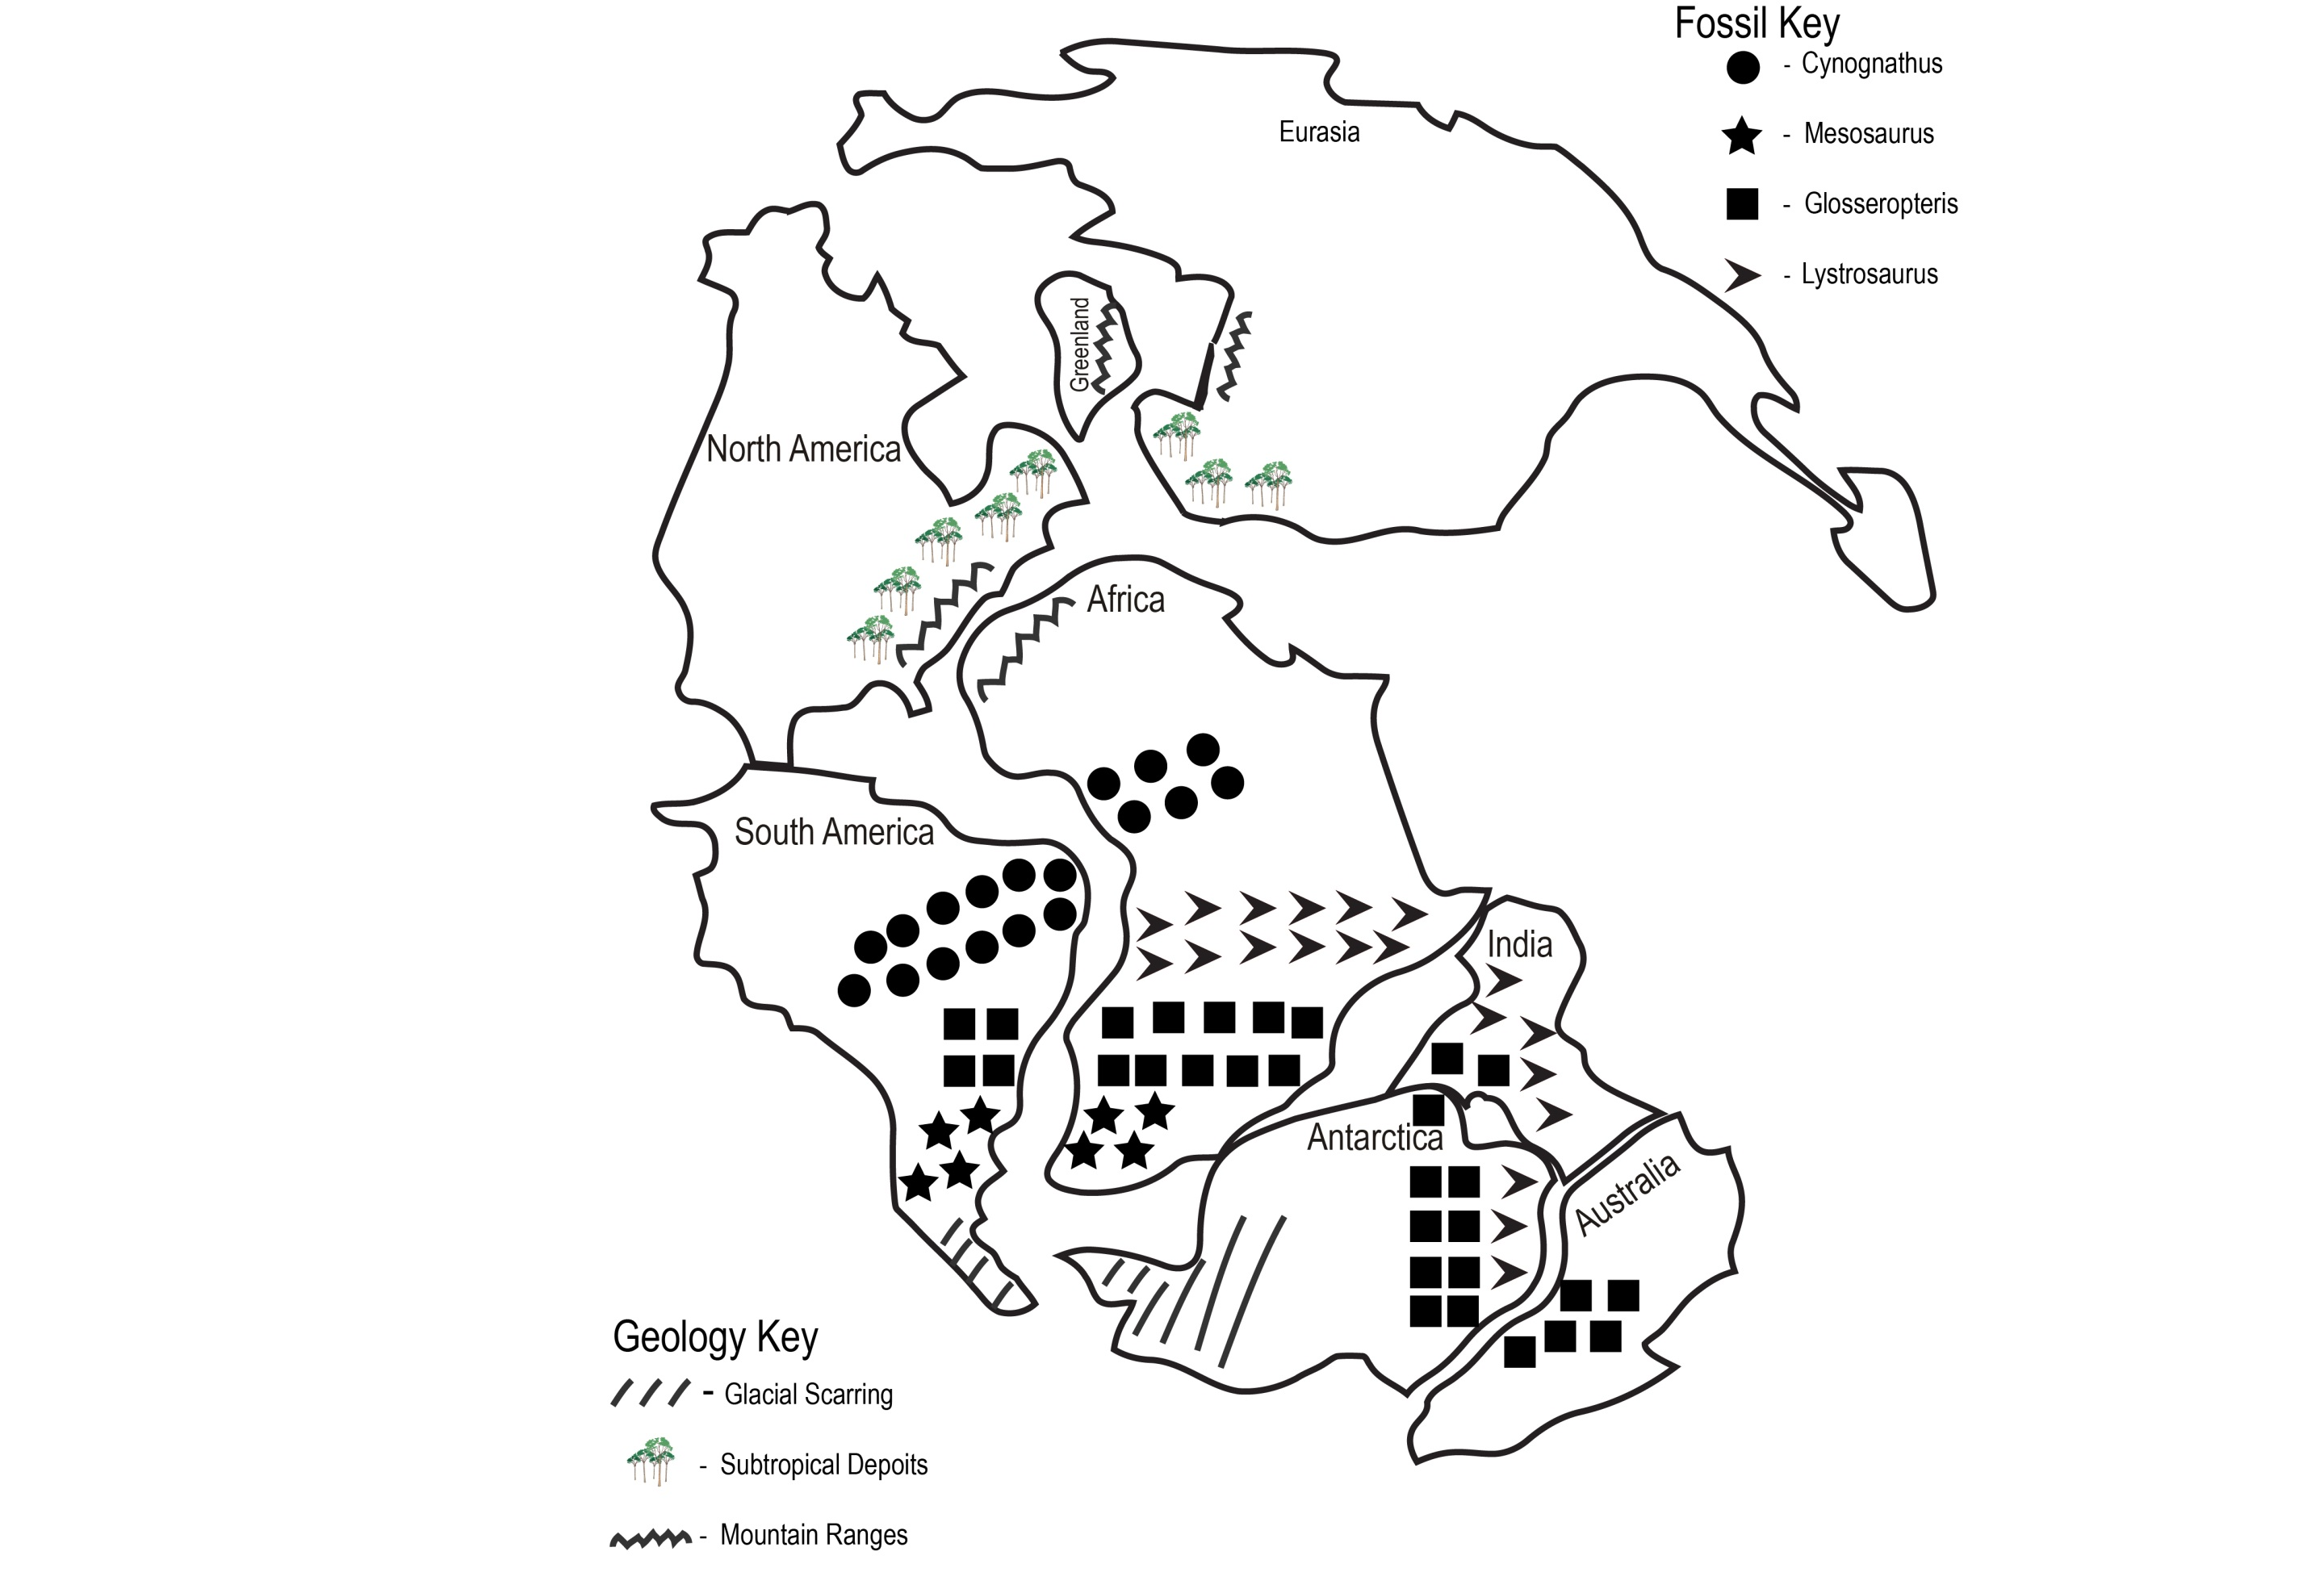
Pangea Puzzle Answer key

Where is your school?
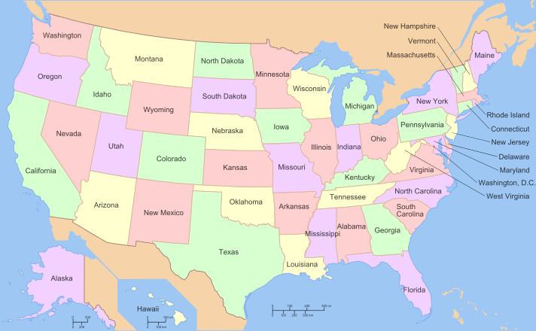
Distance Learning Pre-program Activity #2
Image Source: http://en.wikipedia.org/wiki/United_States

Time required: 30 - 45 minutes
Procedures:
- Students can work individually, in pairs, or as a class with the teacher leading.
- They can use the internet, text resources, and maps to answer the questions about the location of your school and Petrified Forest National Park on the Student Worksheet.
Materials Needed:
- Maps of the United states
- Rulers or tape measures
- Pencil and paper
Lesson overview:
Students will practice math skills while learning where Petrified Forest National Park and their school are located on a map of the U.S
Lesson Objectives:
- Locate Arizona, Petrified Forest NP, and the state where their school is located on a map of the United States
- Use the scale of a map to determine actual distance between two locations
- calculate distance, time, and speed using multiplication and division
- convert a quantity of hours that contains decimals into a measurement of hours and minutes (ex 2.5 hours = 2 hours and 30 minutes)

‘Where is Your School?’ Student Worksheet.
Name _________________________ Date ___________
Petrified Forest Location information: Address – 1 Park Rd. Petrified Forest, AZ 86028, Lat/Lon: 35.2°N 111.62°W, Highest Elevation: 6983 ft
- In which state is your school located?

- In which state is Petrified Forest located?

- How many states you would have to cross to get to Petrified Forest in a straight line?

- What is the shortest distance in miles from your school to Petrified Forest National Park? (Hint: You can look at a map of the U.S. that has a scale and use a ruler to measure the distance from point A to point B then find the distance in miles by using the scale.)

- How many hours would it take to get from your school to Petrified Forest in a car going 60 mph?

- How many hours would it take to get from your school to Petrified Forest in a plane going 550 mph?

(Bonus questions: The average person walks 3 mph. How many hours would it take a person to walk from your school to Petrified Forest? What other national park sites are in the same state as Petrified Forest? What national park sites are in the same state as your school?)
D
S
T

How to calculate Distance, Time, and Speed:
Distance (miles) = Speed (mph) × Time (hours)
Speed (mph) = Distance (miles) ÷ Time (hours)
Time (hours) = Distance (miles) ÷ Speed (mph)

Ex. If your school is 150 miles away from Petrified Forest calculate 150 divided by 60 (mph) to get 2.5 hours, or 2 hours and 30 minutes of travel time.

